Leveraging larger markets to encourage innovation in prosthetics: Design of myopen, an open myoelectric signal processor for use as an input device for video gaming and hobby robotics
Timothy Hanson and Jonathan Kuniholm
Duke University and The Open Prosthetics Project
Abstract
The prosthetic arm market is small; perhaps 70,000 people lack arms in the US. This, coupled with the difficulty of making and controlling a mechatronic hand replacement, has forestalled innovation in arm prostheses in the fifty years since its introduction. Since the Boston Arm project in 1965, the popular press has promised thought-controlled prosthetic arms, yet the promises of scientific research have not often been kept in the clinic.[] We aim to surmount these obstacles by developing an open myoelectric signal processor targeted at researchers, hobbyists, and video game enthusiasts. Our device is capable of processing 16 channels of surface electromyographic (EMG) (or other data), applying pattern recognition algorithms in real-time via a power-efficient Blackfin Digital Signal Processor (DSP), and delivering the results through ethernet, I2C, RS232, USB, and Lego NXT bus. We hope that this open, commodity level platform will become a disruptive technology, encouraging experimentation in the algorithms and applications of a field that has been sequestered too long in the research lab.

BACKGROUND
Much recent media attention about prosthetic arms has surrounded the Defense Advanced Projects Administration (DARPA) Revolutionizing Prosthetics Program (RP2007/2009) and military amputees from recent conflicts. There remains a disconnect between the reality facing an arm amputee and this coverage in the popular press. As of 2007, there were fewer than 700 US military amputees from Iraq and Afghanistan, of whom fewer than 150 were arm amputees.[] Despite the relatively small numbers involved, the media coverage may have brought a welcome increase in efforts to improve arm technology. The DARPA prosthetic program has been compared to the Manhattan Project and the race to put a man on the moon.[] While perhaps an apt comparison in terms of the technical challenges presenting the researchers, the comparison of project budgets in Figure 1 shows that the Revolutionizing Prosthetics Program budgets represents a small fraction of the size of those of the two historical projects. The massive historical efforts in fact compare in size to the R & D costs alone of the current F-35 Joint Strike Fighter program.[,,,]
The deficiency that these programs seek to correct is a basic lack of widely adopted advanced upper extremity products. Many amputees, despite being fitted with myoelectrics, return to body powered designs that have changed little in fifty years. Powered products remain slower, heavier, more fragile and more uncomfortable than the alternatives. This is no fault of the companies that serve arm amputees, but the result of a convergence of factors: the small market size, and the difficulties of the problem of replacing an arm. It is not clear that these realities will make the transition of the impressive technology developed by the RP2007/2009 teams to commercial products any easier. It is this “last mile” of the transfer of technology that we have sought to address with this project.

Figure 1: Budgets (Billions of 2006 Dollars)[4-7]
What is it that separates mass markets from underserved ones? The distribution and therefore lowering of costs, in research and development, manufacturing and distribution to a large number of users. It is also the commodification of products in the marketplace, reducing profit margins because of the availability of alternatives. As illustrated in Figure 2, the buying power in the current market for powered arms cannot hope to challenge that for razors and blades.[,,,] The ability of these larger markets to overcome higher fixed cost barriers to entry explain the pace of innovation in those areas.
Figure 2: Recent Annual Sales ($Billions)[8-11]
PARASITIZING A LARGER MARKET TO LEVERAGE TECHNOLOGY
Pattern Recognition
While other avenues exist for overcoming these barriers, the one that we have chosen is to seek application in markets with fewer limitations in buying power for underused technology in which we are interested. One of the most promising possibilities for prosthetic arm control is myoelectric pattern recognition. Despite more than 20 years of research in this area, and the advent of prosthetic hands with kinematic capabilities exceeding the possibilities for conventional control, no commercial product in arm prosthetics uses it. In order to help make this or any other advanced signal processing technology more accessible to amputee users (and manufacturer and prosthetist users), we have created a product that makes it possible to use pattern recognition or any other signal processing algorithm on skin surface EMG signals for a variety of applications.
In support of the project, a Matlab code base has been generously provided by Dr. Kevin Englehart at the University of New Brunswick (UNB), in Fredericton, Canada. The software, named CEVEN, contains code written by Dr. Englehart and his students, and was assembled into a single package by Blair Lock. This package provides training, classification of EMG signals through a variety of methods, and visual simulation of arm movements that can be paired with pattern recognition. UNB provides no support for the software, and all support and discussion should be maintained through the Google Code site: http://code.google.com/p/myopen/. Ultimately, the project seeks to port the code to a python or similar high level and free platform, but the Matlab version is available in the meantime.
Using the Power of the Video Game Market
Of the collection of large mass markets shown in Figure 2, that for video games and game hardware is the largest. Worldwide spending is almost $18 billion on items for this type of entertainment. The industry has recently undergone several transformations in human interface, from the use of wireless and accelerometer technology in the Wii controller, to the Emotiv controller's use of EEG signals for “brain control”. Pattern recognition is an obvious very capable addition to the battery of ways in which humans can intuitively interact with a virtual world.
Openness Ensures Access to Technology
To ensure that all stakeholders can actually take advantage of the benefits that come from the use of pattern recognition in the video game market, we have chosen to release both our hardware and software designs under the open source GNU Public License. By ensuring that the designs will always be freely available and changeable, we can break down the silos that separate different uses for the technology, allowing user customization for purposes that we have not yet envisioned.
This approach has been around for a while in software, but is relatively new in hardware. Several current devices use it, including the Neuros OSD video device, and the Buglabs BUG. The multi-purpose linux BUG device with swappable and easily configurable components includes a GPS, touch screen and motion sensor, with which users can make their own embedded devices. Because of the added complexities involved in dealing with the physical world, this approach is still very much the beginning of an experiment.
TECHNICAL DETAILS
Our first iteration of the MyOpen EMG signal processor is based on the Blackfin DSP and has a number of features to encourage development, customization, and interfacing to the greater world. The board for this device is effectively broken into two parts: the digital section, including the DSP and all communication ports, and the analog section. The two sections are electrically isolated for safety.
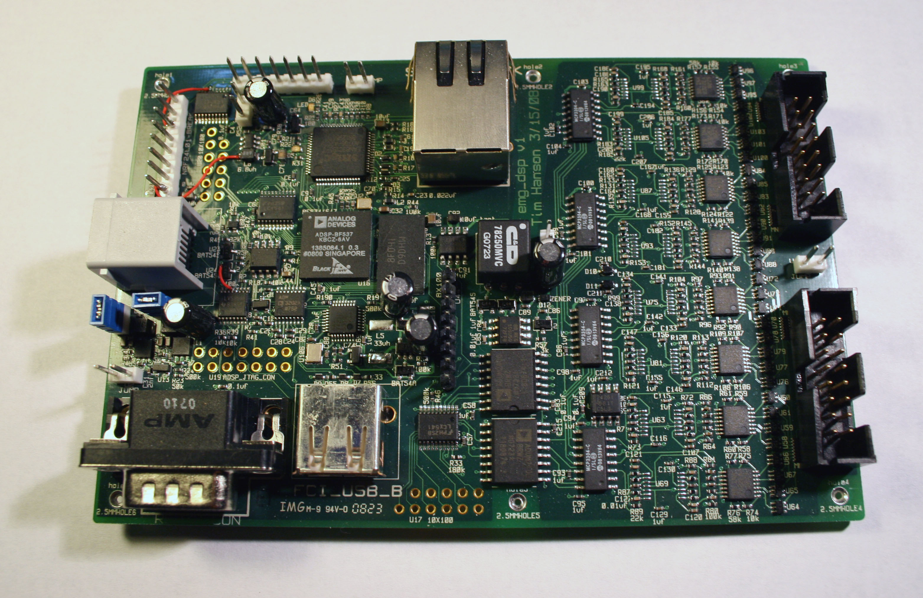Figure 3: The MyOpen EMG Digital Signal Processor
The analog section consists of 16 channels of differential EMG amplification. At the head of this signal chain is a low-cost, low power instrumentation amplifier(INA2322) followed by a high pass (fc = 1hz) and a low-pass (fc = 400hz) stage. Both filtering stages are in a multiple-feedback configuration, and both provide a gain of 4; the instrumentation amplifier provides a gain of 30 for a total system gain of about 480 (54dB). The filtered EMG signal is digitized at a resolution of 13 bits with the four-channel MCP3304, and this data is sent to the digital section of the board via ADUM2400 magnetic isolators. The analog section has a 0/2.5/5v split-rail powered via a MAX253, transformer, and low-noise regulator.
The digital section features the DSP, 32Mbytes SDRAM, ethernet PHY & magjack, RS232, USB, JTAG, and Lego NXT compatible I2C / TWI. The board also features a small 128x128 pixel serial LCD for debugging and user interface, as well as header breakouts for 8 general-purpose pins on the DSP. Each of these devices may be powered down to conserve battery power. Furthermore, a low-power pin-compatible Blackfin BF534 chip may be substituted in for the faster BF537 when the ethernet interface is not required. The core voltage for the Blackfin may be runtime switched between 0.8V and 1.2V, again to save power. This and the system 3.2V bus are supplied through two efficient synchronous buck converters from either a 3.7V lithium cell or a 5V external supply.
The first revision of the board is 6 layers, routed on 0.005” trace/space rules, with 0.006” minimum via hole under the DSP/SDRAM, and is 3.3”x4” in dimensions. The board can be made smaller in the future by placing components on both sides.
The first revision of the board is 6 layers, routed on 0.005” trace/space rules, with 0.006” minimum via hole under the DSP/SDRAM, and is 3.3”x4” in dimensions. The board can be made smaller in the future by placing components on both sides.

1. Feron, J., “New Process Will Help Amputee To Control Limb With Thought”, New York Times, August 16, 1965.
2. Carey, B. and Belfiore, M., “Bionic Made Better”, Popular Science Scitech (http://www.popsci.com/scitech/article/2007-08/bionic-made-better), August 22, 2007.
3. Adee, S., “A 'Manhattan Project' for the Next Generation of Bionic Arms,” IEEE Spectrum Online (http://www.spectrum.ieee.org/mar08/6069), March, 2008.
4. Schwartz, S.I. “Atomic Audit: The Costs and Consequences of U.S. Nuclear Weapons”, Washington, D.C., Brookings Institution Press, 1998.
5. Ezell, LN, "NASA Historical Data Book," Vol. II, NASA SP-4012, 1988, pp. 122-32.
6. Bolkcom, C. , "Joint Strike Fighter (JSF) Program: Background, Status, and Issues." Congressional Research Service Report: 12, 2002.
7. Department of Defense Fiscal Year (FY) 2005-2009 Budget Estimates, February 2006, February 2007, February 2008. Research, Development, Test And Evaluation, Defense-Wide. Volume 1 - Defense Advanced Research Projects Agency.
8. CNN Money, “Gillette unveils 5-bladed razor”, (http://money.cnn.com/2005/09/14/news/fortune500/gillette/), September 14, 2005.
9. Gilbert, S., “NPD December and 2007 Gaming Results: Incredible Video Game Sales”, Metue Media Entertainment and Technology (http://metue.com/01-17-2008/npd-december-2007-annual-videogame-sales/), January 17, 2008.
10. Smith, A., “Sex dysfunction drugs: Nowhere to grow?”, CNN Money (http://money.cnn.com/2006/01/05/news/companies/sexdysfunction/), January 5, 2006.
11. Dishneau, D., “War fuels prosthetics research blitz”, USA Today, July 16, 2007.

- Feron, J., “New Process Will Help Amputee To Control Limb With Thought”, New York Times, August 16, 1965.
- Carey, B. and Belfiore, M., “Bionic Made Better”, Popular Science Scitech (http://www.popsci.com/scitech/article/2007-08/bionic-made-better), August 22, 2007.
- Adee, S., “A 'Manhattan Project' for the Next Generation of Bionic Arms,” IEEE Spectrum Online (http://www.spectrum.ieee.org/mar08/6069), March, 2008.
- Schwartz, S.I. “Atomic Audit: The Costs and Consequences of U.S. Nuclear Weapons”,Washington, D.C., Brookings Institution Press, 1998.
- Ezell, LN, "NASA Historical Data Book," Vol. II, NASA SP-4012, 1988, pp. 122-32.
- Bolkcom, C. , "Joint Strike Fighter (JSF) Program: Background, Status, and Issues." Congressional Research Service Report: 12, 2002.
- Department of Defense Fiscal Year (FY) 2005-2009 Budget Estimates, February 2006, February 2007, February 2008. Research, Development, Test And Evaluation, Defense-Wide. Volume 1 - Defense Advanced Research Projects Agency.
- CNN Money, “Gillette unveils 5-bladed razor”, (http://money.cnn.com/2005/09/14/news/fortune500/gillette/), September 14, 2005.
- Gilbert, S., “NPD December and 2007 Gaming Results: Incredible Video Game Sales”, Metue Media Entertainment and Technology (http://metue.com/01-17-2008/npd-december-2007-annual-video-game-sales/), January 17, 2008.
- Smith, A., “Sex dysfunction drugs: Nowhere to grow?”, CNN Money (http://money.cnn.com/2006/01/05/news/companies/sexdysfunction/), January 5, 2006.
- Dishneau, D., “War fuels prosthetics research blitz”, USA Today, July 16, 2007.

